Engagement 1

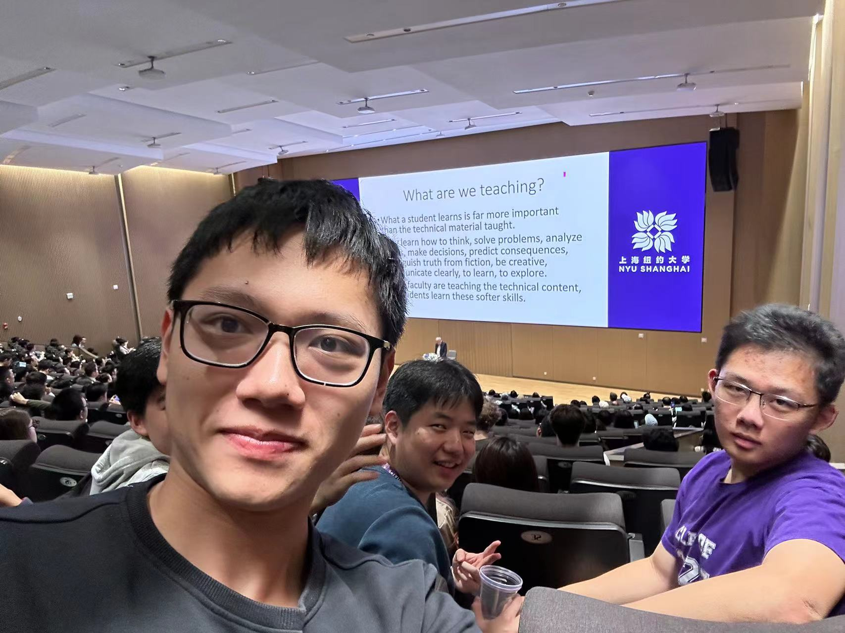

Activities:Turing Award Laureate John Hopcroft in Conversation with Jeff Lehman

Date:2023/10/25

Description:The lecture topic is behind the scenes of a University Education.It was lectured by the world-renowned computer scientist,turing Award laureate,John.He mainly talks about the Chinese college education about the computer science,and its comparison with the other countries. Also,he introduces the research methods including the preparation, putting forward a question and solve the questions during the process of the Turing Award.

Connection:One of the most impressive augment that he talks is that he said Chinese education usually put much attention on the grades and with much homework and publications,which usually do harm to their interest in the research for the true computer science.That is his opinions on the essence of the education.Just like we have read before,Confucius thought had also some opinions on the essence of the education,which he put much importance to the benevolence”ren”. Also with the society changing,the opinions may have some changes in the formal,but I think their opinions still have some relations ,that is the Pursuit of the human natural heart.From professor Jeff Lehman’s opinion is the human’s natural curiosity that can help the research,and Confucius human’s natural benevolence is good for the society.